OUR PRODUCTS

Our products mix is composed of 3 types of products listed as follows:

[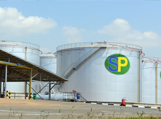](https://www.vps-lubricants.com/products/aviation/)

Fuels

With the largest distribution channel in Rwanda, SP has petrol stations across the country. SP is also engaged in home bulk deliveries, aircraft fueling and export to the region. Below are different fuels:

• Petrol  
• Diesel  
• Kerosene  
• Jet A1  
• Bitumen  
• HFO (heavy fuel oil)  
• LFO (light fuel oil)

[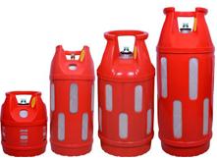](javascript:void%7b0%7d)

LPG

*Cylinder levels*

Our Liquefied Petroleum Gas (LPG) is sold in different levels measured in Kilograms. We have cylinders of:

• 6Kgs   
• 12Kgs   
• 15Kgs   
• 20Kgs   
• 38Kgs

The above cylinders are of two types:

• Composite cylinder   
• Metal Cylinder   
• Bulk Deliveries: LPG Tank and installation. This is a facility for big institutions (e.g: Hotels, Schools, Hospitals, big entities etc)

SP has a filling LPG plant and is planning to expand it and build a bigger plant to meet the customer needs and requirements.

SP sells also different LPG accessories including cookers and regulators.

[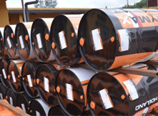](https://www.rymax-lubricants.com/)

Lubricants

In a partnership with RYMAX brands from Netherlands, SP is engaged in selling different types of lubricants:

• Engine Oils: Photos  
• Industrial Oils Photos  
• Special Oils Photos

SP is planning to open a lubricant plant locally located to efficiently satisfy the local demand.